**Software Process Selection and Project Plan**

**P11:Blood Donation System**

**<team member names & ids>**

|  |  |
| --- | --- |
| **Student ID** | **Name** |
| **22100221** | **Ahmad Aslam** |
| **22100082** | **Saad Azam** |
| **22100224** | **Muhammad Bilal** |

**Table of Contents**

1. Introduction 3
2. Software Process Selection 4
3. Gantt Chart 8
4. Risk Management 9
   1. Potential Risks and Mitigation Strategies 9
5. Development Environment Preparation 11
6. Deployment Platform 26

6.1 Heroku: 26

6.2 S3 Bucket: 26

6.3 Heroku DB: 26

1. Who Did What? 27
2. Review checklist 27

# Introduction

Blood Donating System is an Android, iOS and web-based app that provides a platform to blood donors and receivers for successful blood donation. It is going to make blood donation accessible to the one in need. The potential users of the app are blood donors, NGOs and blood recipients.

The overall objectives of the app are:

* Expedite the process of blood donation.
* Encourage NGOs to provide blood donors to the system.
* Through a system of ratings, points and rewards, encourage more and more donors to use the app.
* Provide an easy communication between blood donors and blood receivers.
* Make blood donation easily accessible to the one in need.

In the app, a recipient is going to ask for a donation of blood. The request will be pushed to a newsfeed where a donor will willingly respond to the request. A chat module will open between the donor and the receiver where they can communicate regarding the blood donation. On successful blood donation, the donor will be rewarded with points.

The app is going to be android, iOS and web-based. The main technologies that we are going to use for our app are Ruby on Rails, React and React Native.

# Software Process Selection

|  |
| --- |
| **Waterfall** |
| Waterfall is a traditional method of software development in which each phase depends on the deliverable of the previous phase. In other words, one phase is developed completely and then the next phase is developed. It is consist of following steps:   1. Requirement Analysis 2. System design 3. Implementation 4. Testing 5. Deployment 6. Maintenance   Sequence of these steps is strictly followed. |
| **PROS:**   * Waterfall focuses on the clear, well defined set of steps which makes its structure easy to understand and use. * Since all the requirements are defined beforehand, it is easy to manage. Time scales and deadlines can be set up easily because of the rigidity of the model. * Phases are completed one at a time which allows developers to focus more on specific tasks. * Waterfall focuses on the end goal from the beginning. Which eliminates the risk of loosing track and it also keeps the team organized. * Information is completely transferred from one phase to other in the form of documents which allows the incorporation of new developers and teams. In other words, it is possible that different phases are done by different teams. |
| **CONS:**   * Major disadvantage of using waterfall model is that it makes changes very difficult. Waterfall is based entirely on following fixes steps so it leaves almost no room for any unexpected changes. * No working software is produced until late during the life cycle. Because of this, there is almost no involvement of client and end user. * No involvement of the client and end user increases the risk and uncertainty. No feedback is available from client or end user until late in the life cycle. And at the end if client or end user dislikes the software and wants to make any changes these changes can hardly be accommodated. * Adjusting scope during life cycle can end the project. * It is difficult to measure progress within the phases. |

|  |
| --- |
| **Agile** |
| The agile methodology is an iterative approach to project management and software development. In agile, project is divided into several phases which are developed and improved continuously with the collaboration of the stakeholders. Agile contains following steps.   * Planning * Analyzing * Architecture design * Coding * Unit testing * Acceptance testing * Delivery * Feedback   In agile there can be many iteration in one specific phase of the life cycle. Every iteration solves some existing problems or incorporated the requirement changes. |
| **PROS:**   * The agile process allows to deliver working software quickly. It might contain a lot of bugs but the feedback of the stakeholders can be taken which helps a lot is improvement of the software. * Due to iterative approach, it is very easy for the project to solve problems and adapt itself to the changes requirements. * Agile methodology requires a lot of collaboration back and forth. The continuous feedback of client and customer and teams creates a positive environment which enhances the quality of project. * Since feedbacks are continuously being exchanged. It is very easy to detect problems in the project. * Risk and uncertainty is very low. |
| **CONS**:   * Lack of documentation is one main disadvantage of using agile methodology. Due to ever changing requirements of the project, document for one phase can become obsolete due to minor or major changes * Flexibility of the agile makes it very hard to manage. Time scales and deadlines for specifics phases are also very hard to set up. * In contrast to the waterfall model it is easy to lose track in agile and team can face difficulties to organize itself. * Due to continuous change in the requirement there is a lack or clarity in the project which leads to many problems. |

# Gantt Chart

Gantt chart link: <https://app.instagantt.com/shared/s/zdBlHQMXawLPcQLyhEx9/latest>

Please visit the link above to view gantt ch

|  |
| --- |
| **Process Selection** |
| We will be using **Agile** methodology for project management and software development.  **Reason:**  Over methodology that we are using in this course is agile where we submit  deliverable and then receive feedback. Then as a whole team we incorporate the changes suggested in the feedback to improve quality of the deliverable. So, agile methodology is well aligned with the course because in upcoming we will be create a working prototype of the system and the improve it sequentially which is basically agile. Moreover, it will help us complete project quickly. Since we are developing a social app which require a lot of feedback from end users so agile is best suitable for us because it will be easy to incorporate changes. Agile is becoming more popular day by day so implementing agile on our project will also give us experience of industry standards. There will be less pressure of the deadlines considering the improvements that we can make in the next iteration.  We will use standard practices to implement agile methodology. We will use Trello for task management. We will divide each phase into small tasks and assign the tasks to different team member. We will also have scrum meeting to evaluate the progress of the project and define the sprints. |

art in detail.

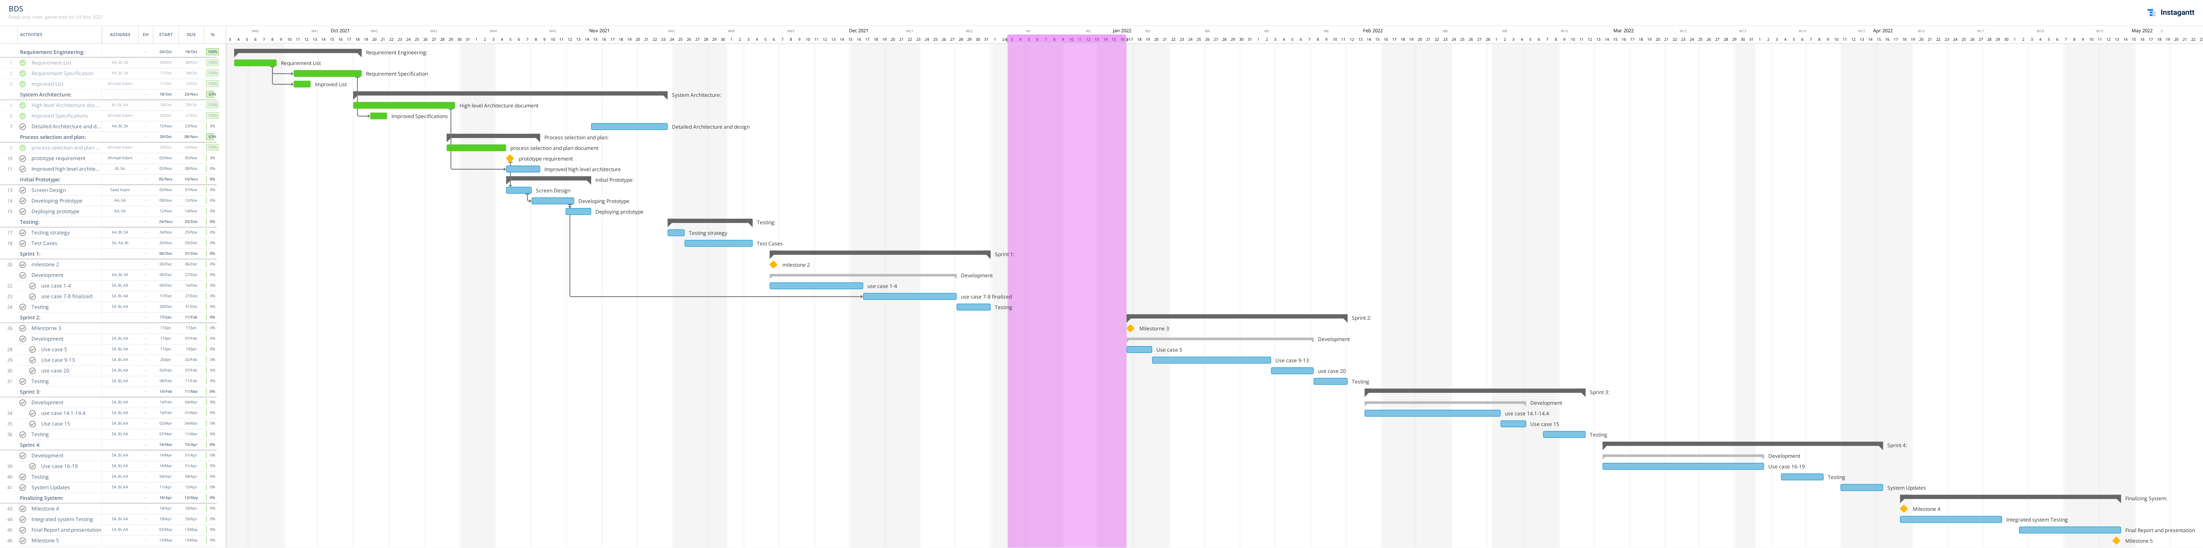

Caption

# Risk Management

## Potential Risks and Mitigation Strategies

|  |  |  |
| --- | --- | --- |
| **Sr.** | **Risk Description** | **Mitigation Strategy** |
|  | **Servers Unavailability risk:**  In case of high traffic, servers can become unavailable and user can get delayed response. | In such situation, owner will be suggested to move to high performing servers to handle heavy traffic, and make system available all time. |
|  | **Operational Risk:**  In case of an issue in working application, it can crash. | Team will identify problem and will work on solving it. It will make application work again within time constraint. |
|  | **Reusable component risk:**  There is risk of faults in reusable components of application, which can make certain application features unavailable. | Our team will identify the fault in component. It will work on resolving it and making it functional for future. |
|  | **Team members Unavailability Risk:**  There is possibility of team members unavailability, that can disturb the normal flow of activities done by team. | Available team will reorganize the tasks, and will do missing work. |
|  | **Requirement Change Risk:**  Change in requirement can happen in future, depending upon customer need. | Team will be notified of change in requirements. It will re-define time constraint for updated requirements.  Also, owner will be notified of a cost change. |
|  | **Team Skill Risk:**  In case of team skillset, there are chances that some team members will not be familiar with tool and technologies project requires. | Team will hold tutorials to get familiarize all team members with the tools and technologies project requires. |
|  | **Security Risk:**  There is risk of data breaching of application users. | Team will identify security issues and will suggest owner to move to more secure system. |
|  | **Performance Risk:**  There is the risk of low performance of application. | In such situation, team will make amendments in tools and technologies it used, for high performance of application. |
|  | **Database risk:**  There is risk of low database performance i.e., it cannot perform expected number of transactions. | In such situation, team will identify the problem and owner will be suggested to move to high performing database. |
|  | **System Feature Risk:**  There is risk that some system features stop working due to unexpected programmatic issue. | Team will get feedback from end users and will resolve the issues. |

# Development Environment Preparation

**Development Tools:**

* 1. Vs code
  2. Figma
  3. Ruby on Rails
  4. React native and node.js
  5. Postman
  6. Trello
  7. Slack
  8. Chrome browser
  9. Heroku
  10. Postgres and PgAdmin

5.1.1: vsCode

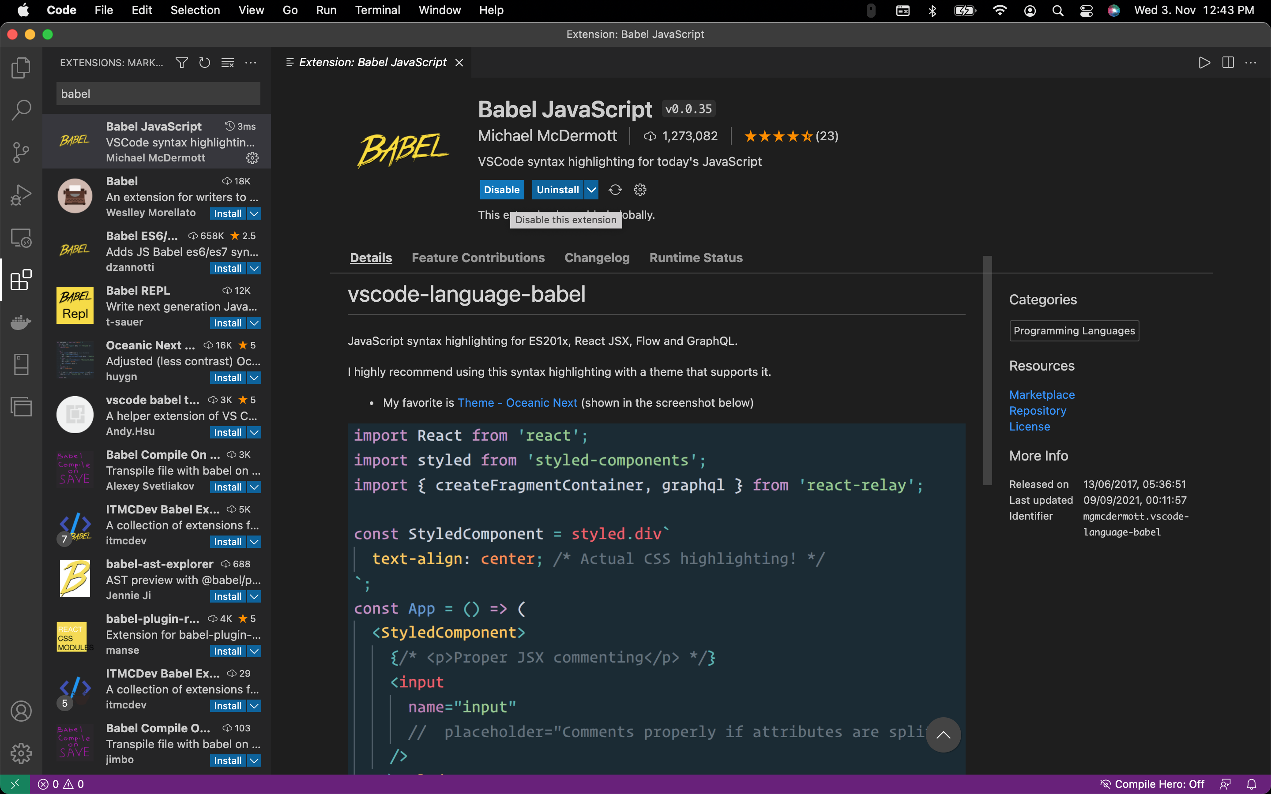

5.1.2: vsCode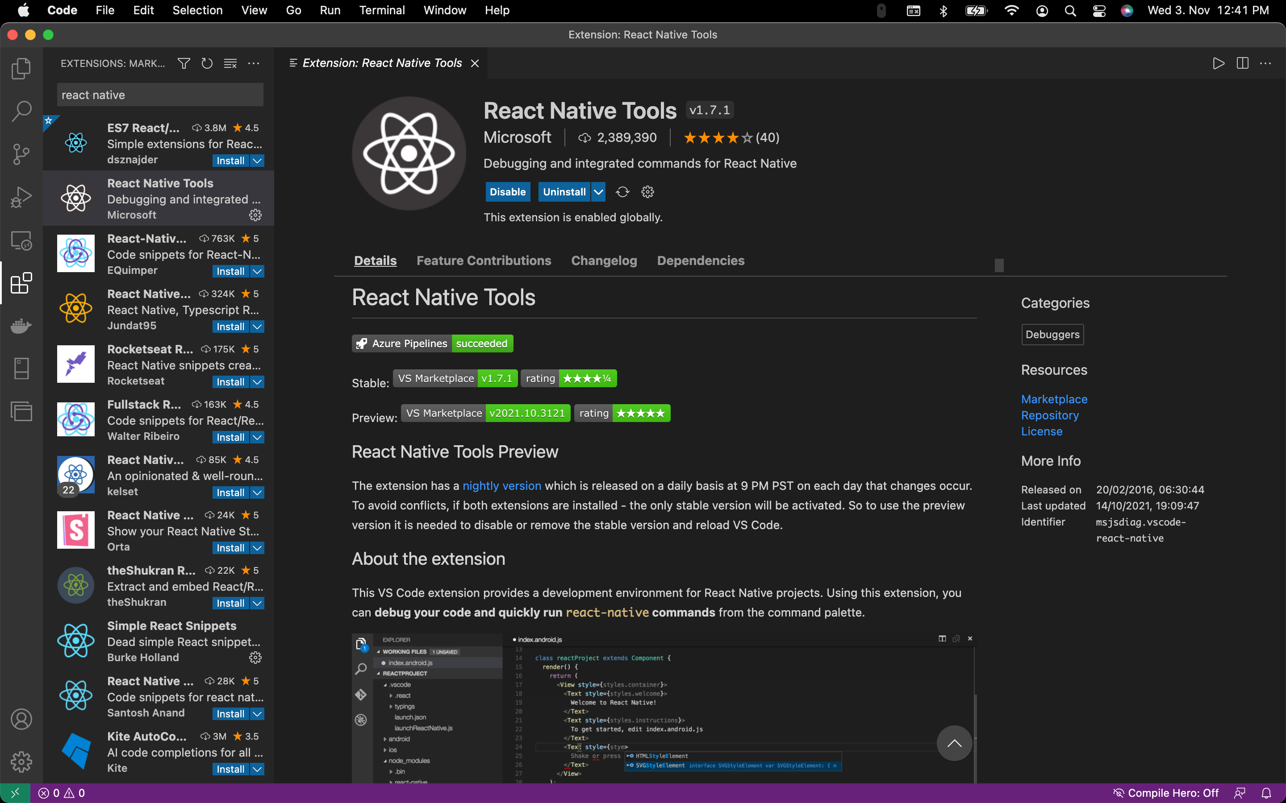

5.4.1 node

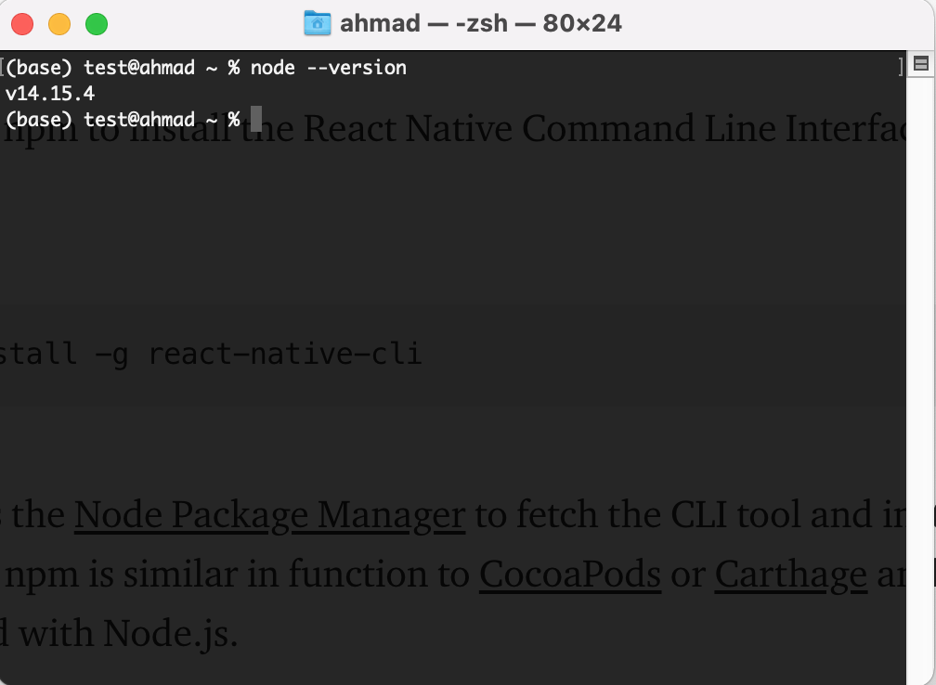

5.4.2 npm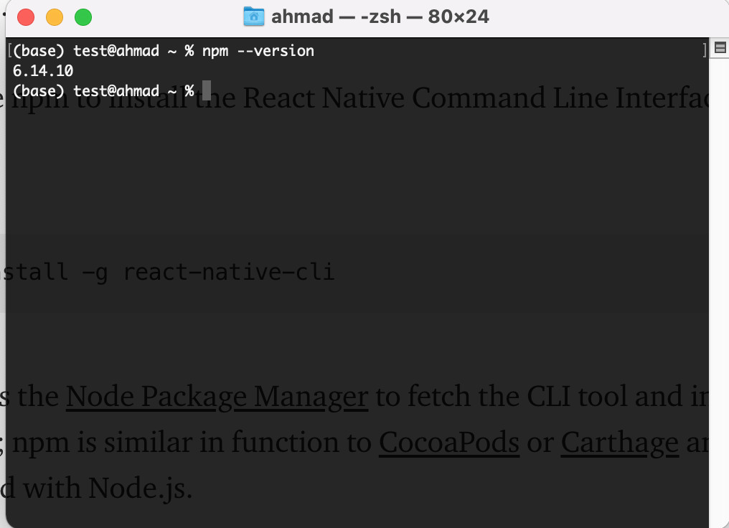

5.4.3 ReactNative app using expo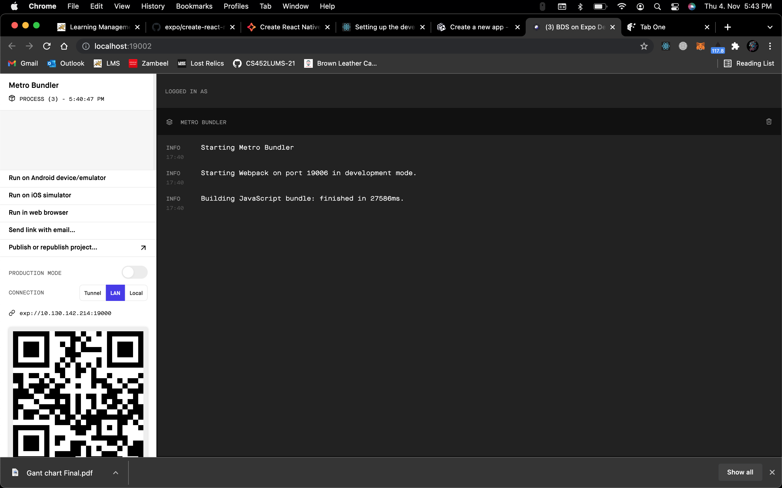

5.4.4 ReactNative app using expo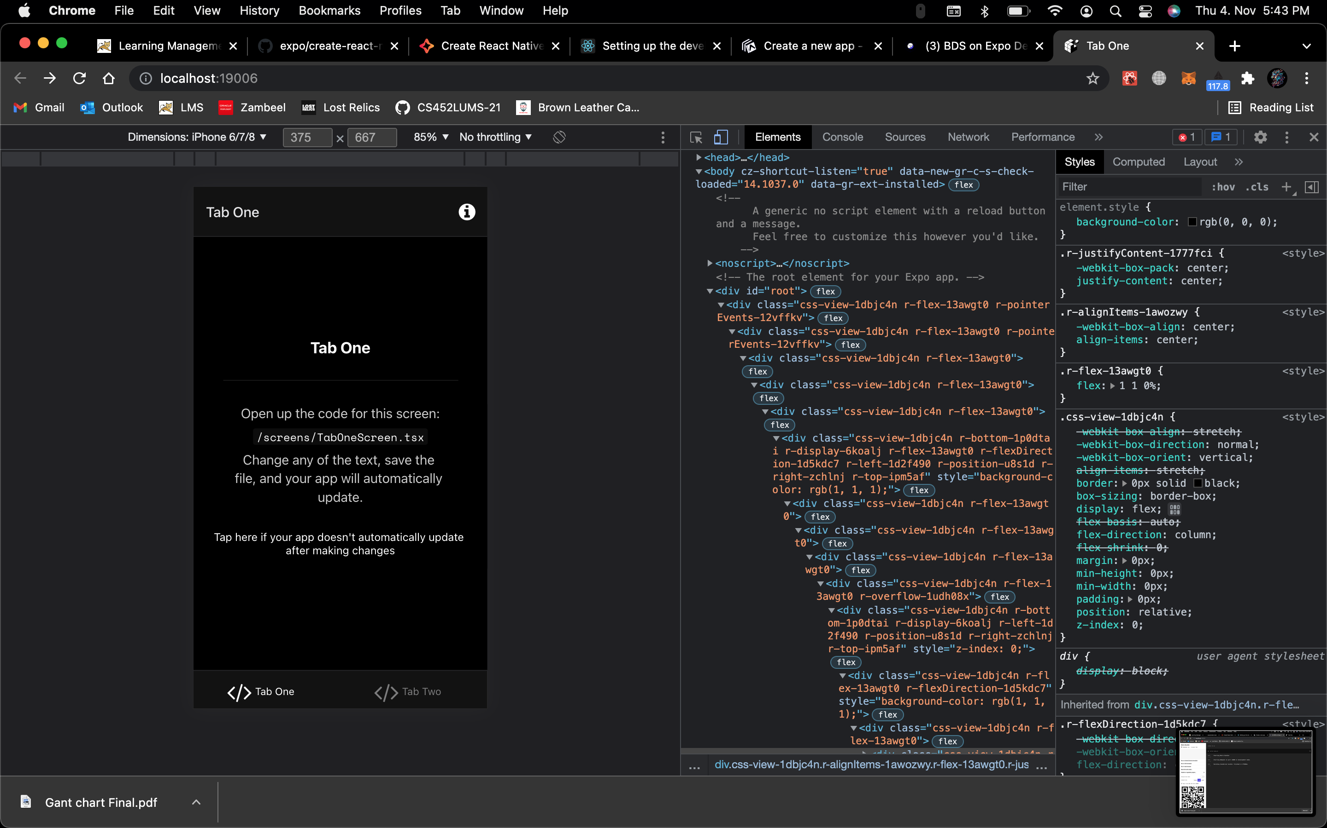

5.5.1 postman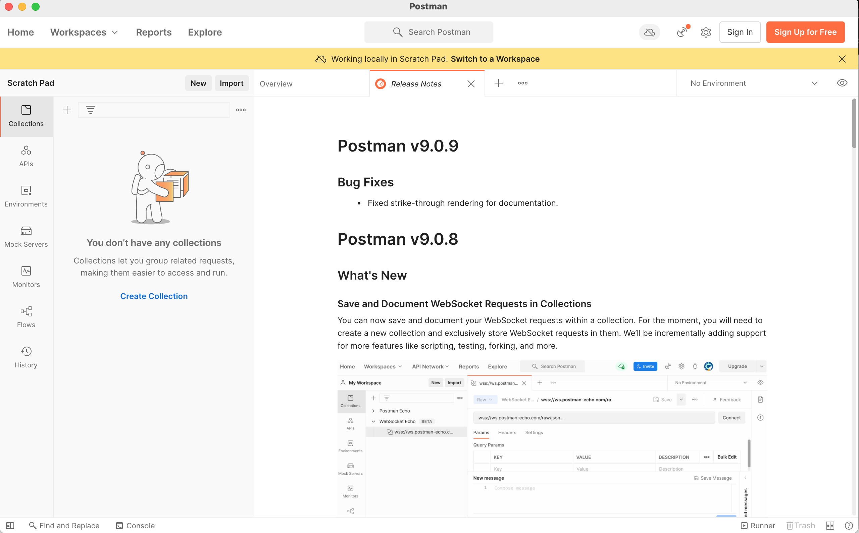

5.5.2 postman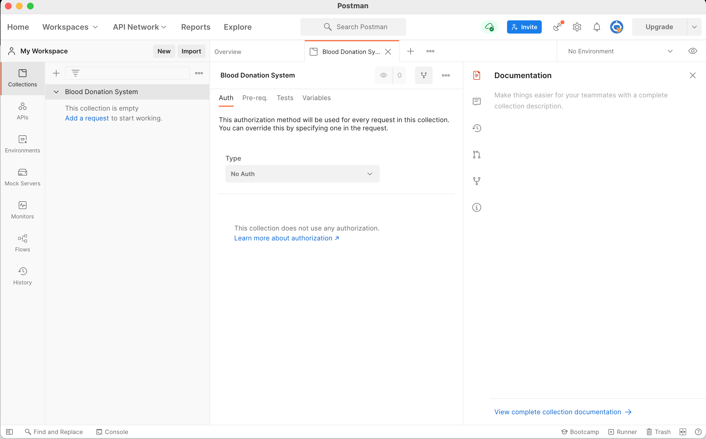

5.5.3 postman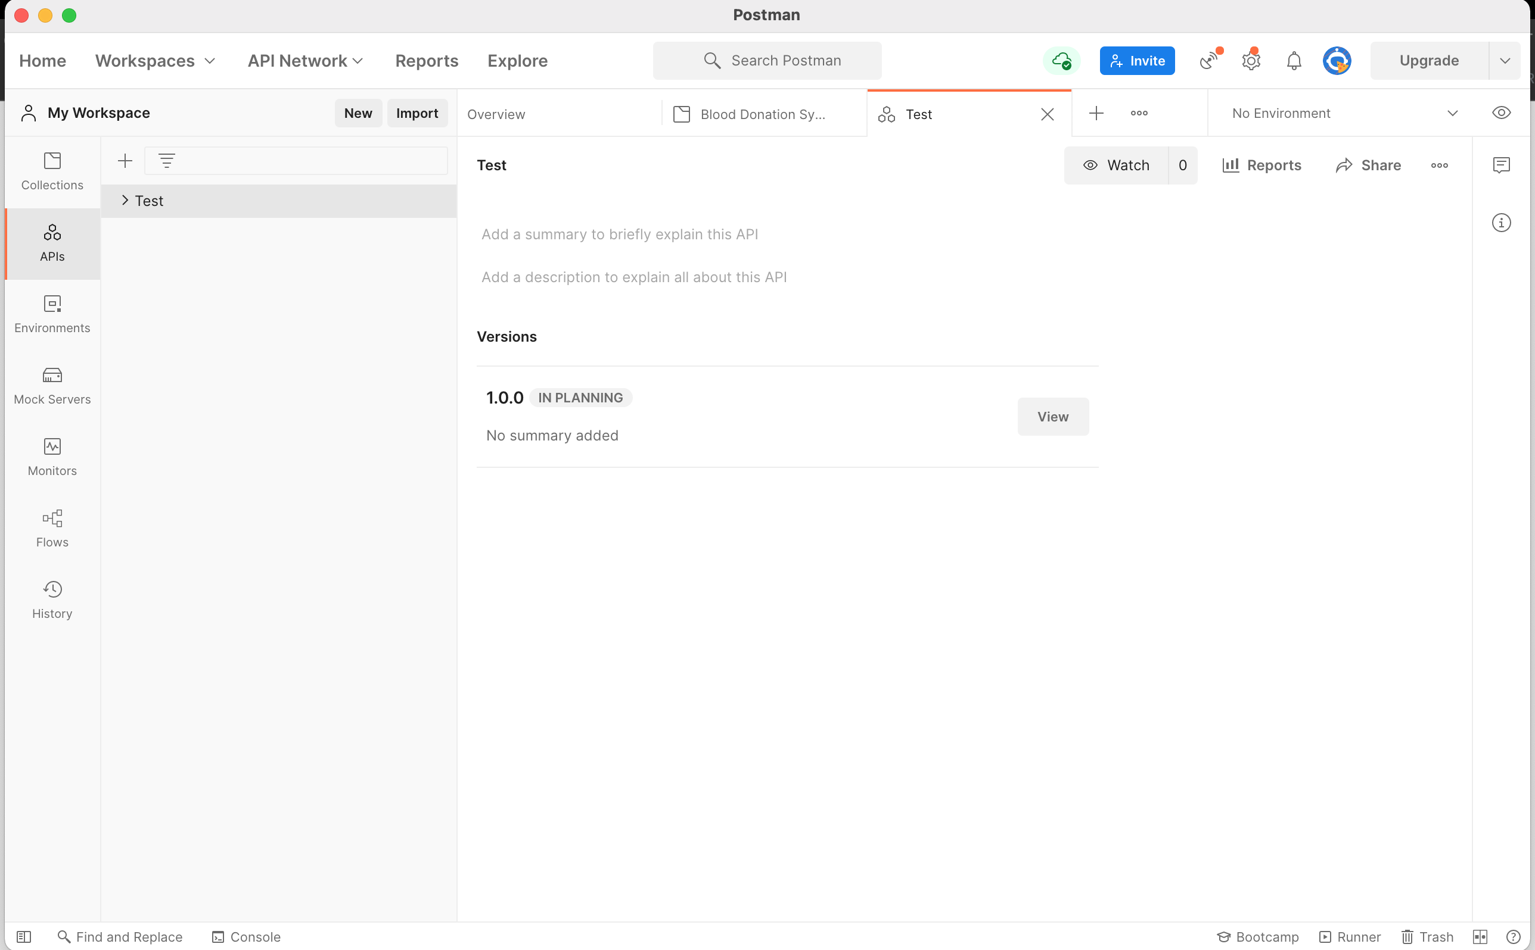

5.6 Trello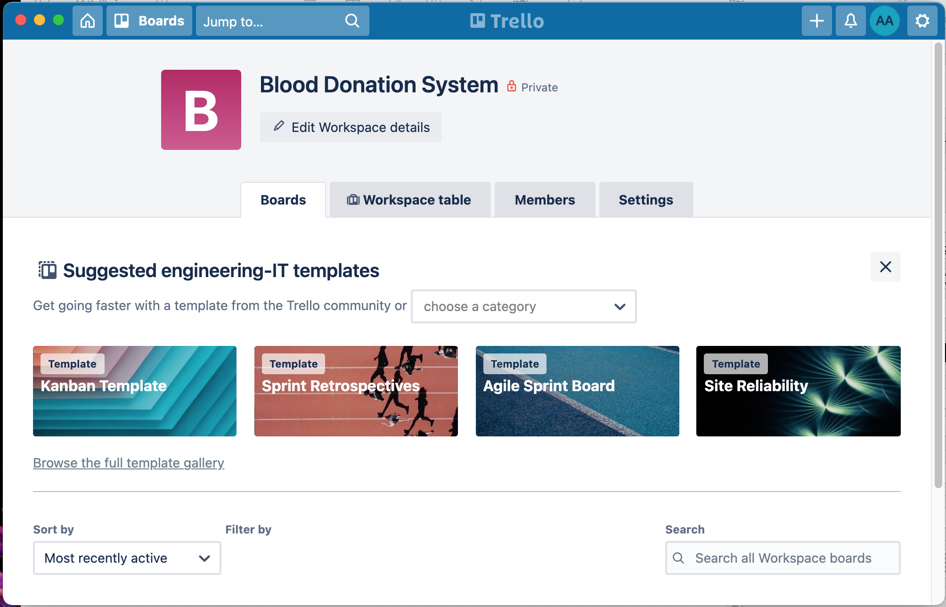

5.7 Slack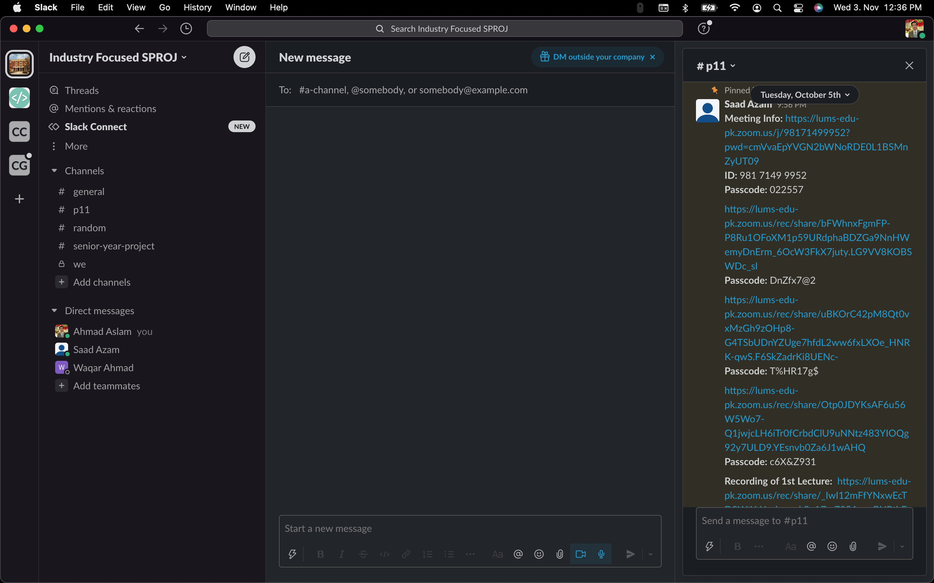

5.8.1 Chrome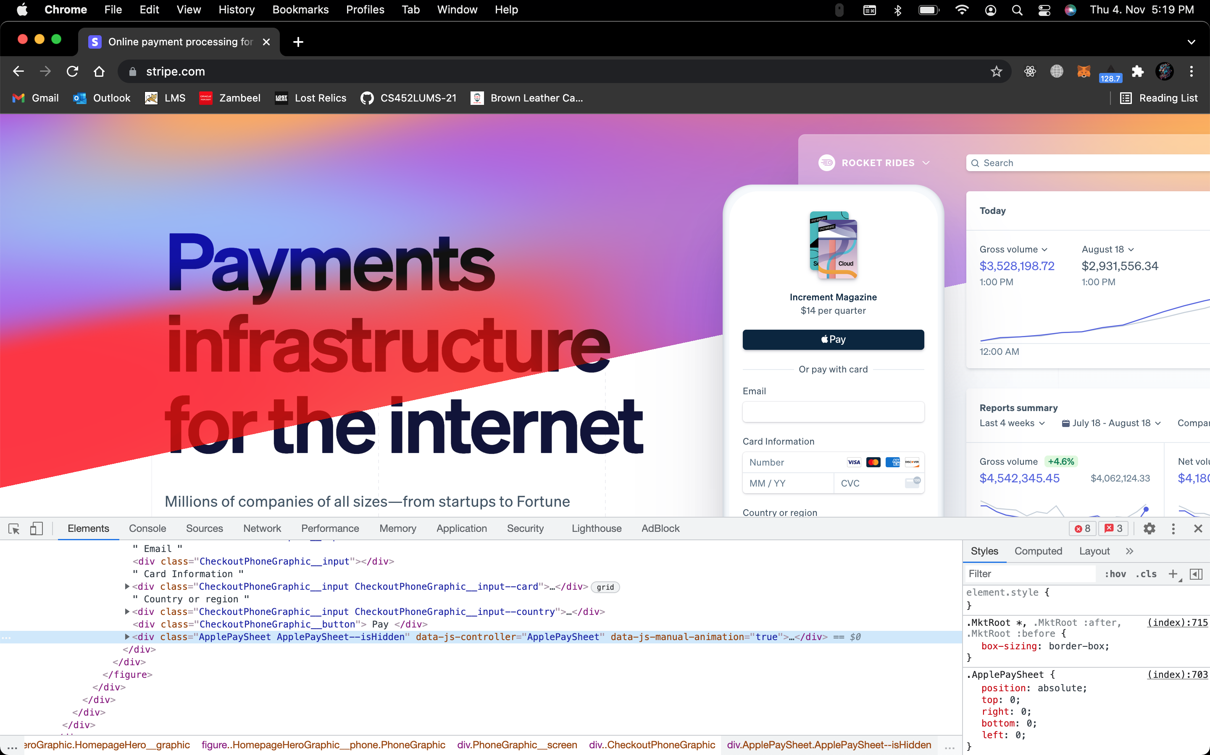

5.8.2 Chrome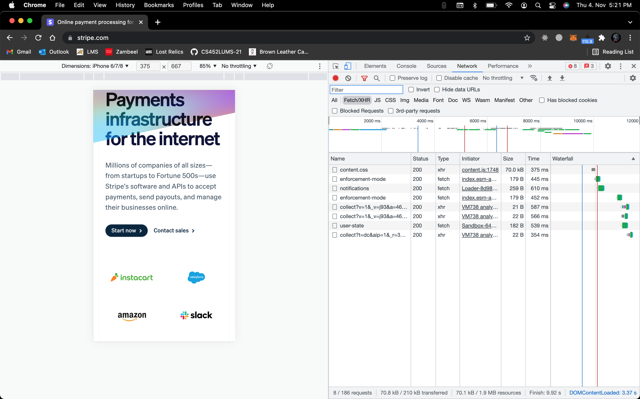

5.9 Heroku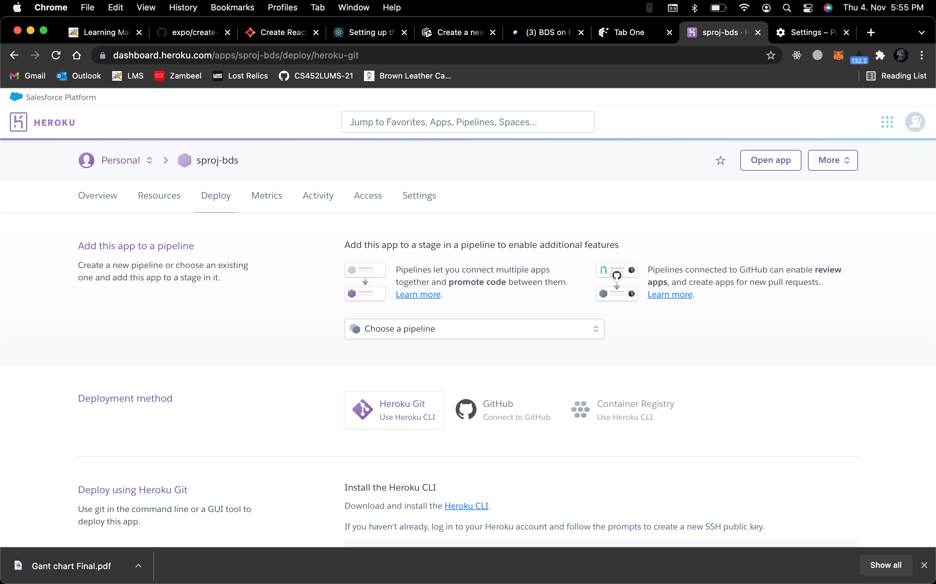

5.10.1 postgres

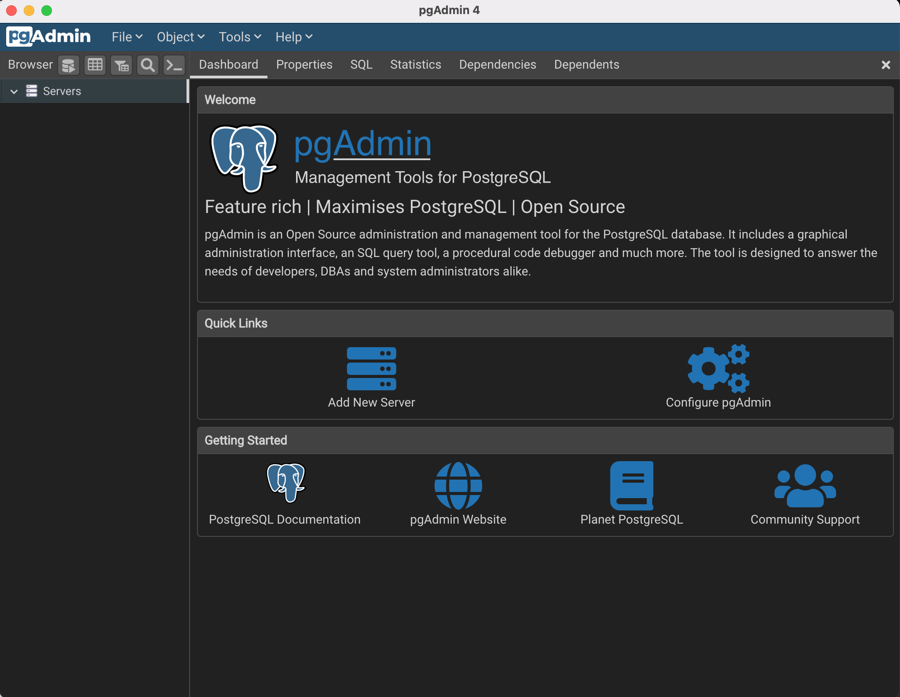

5.10.2 postgres

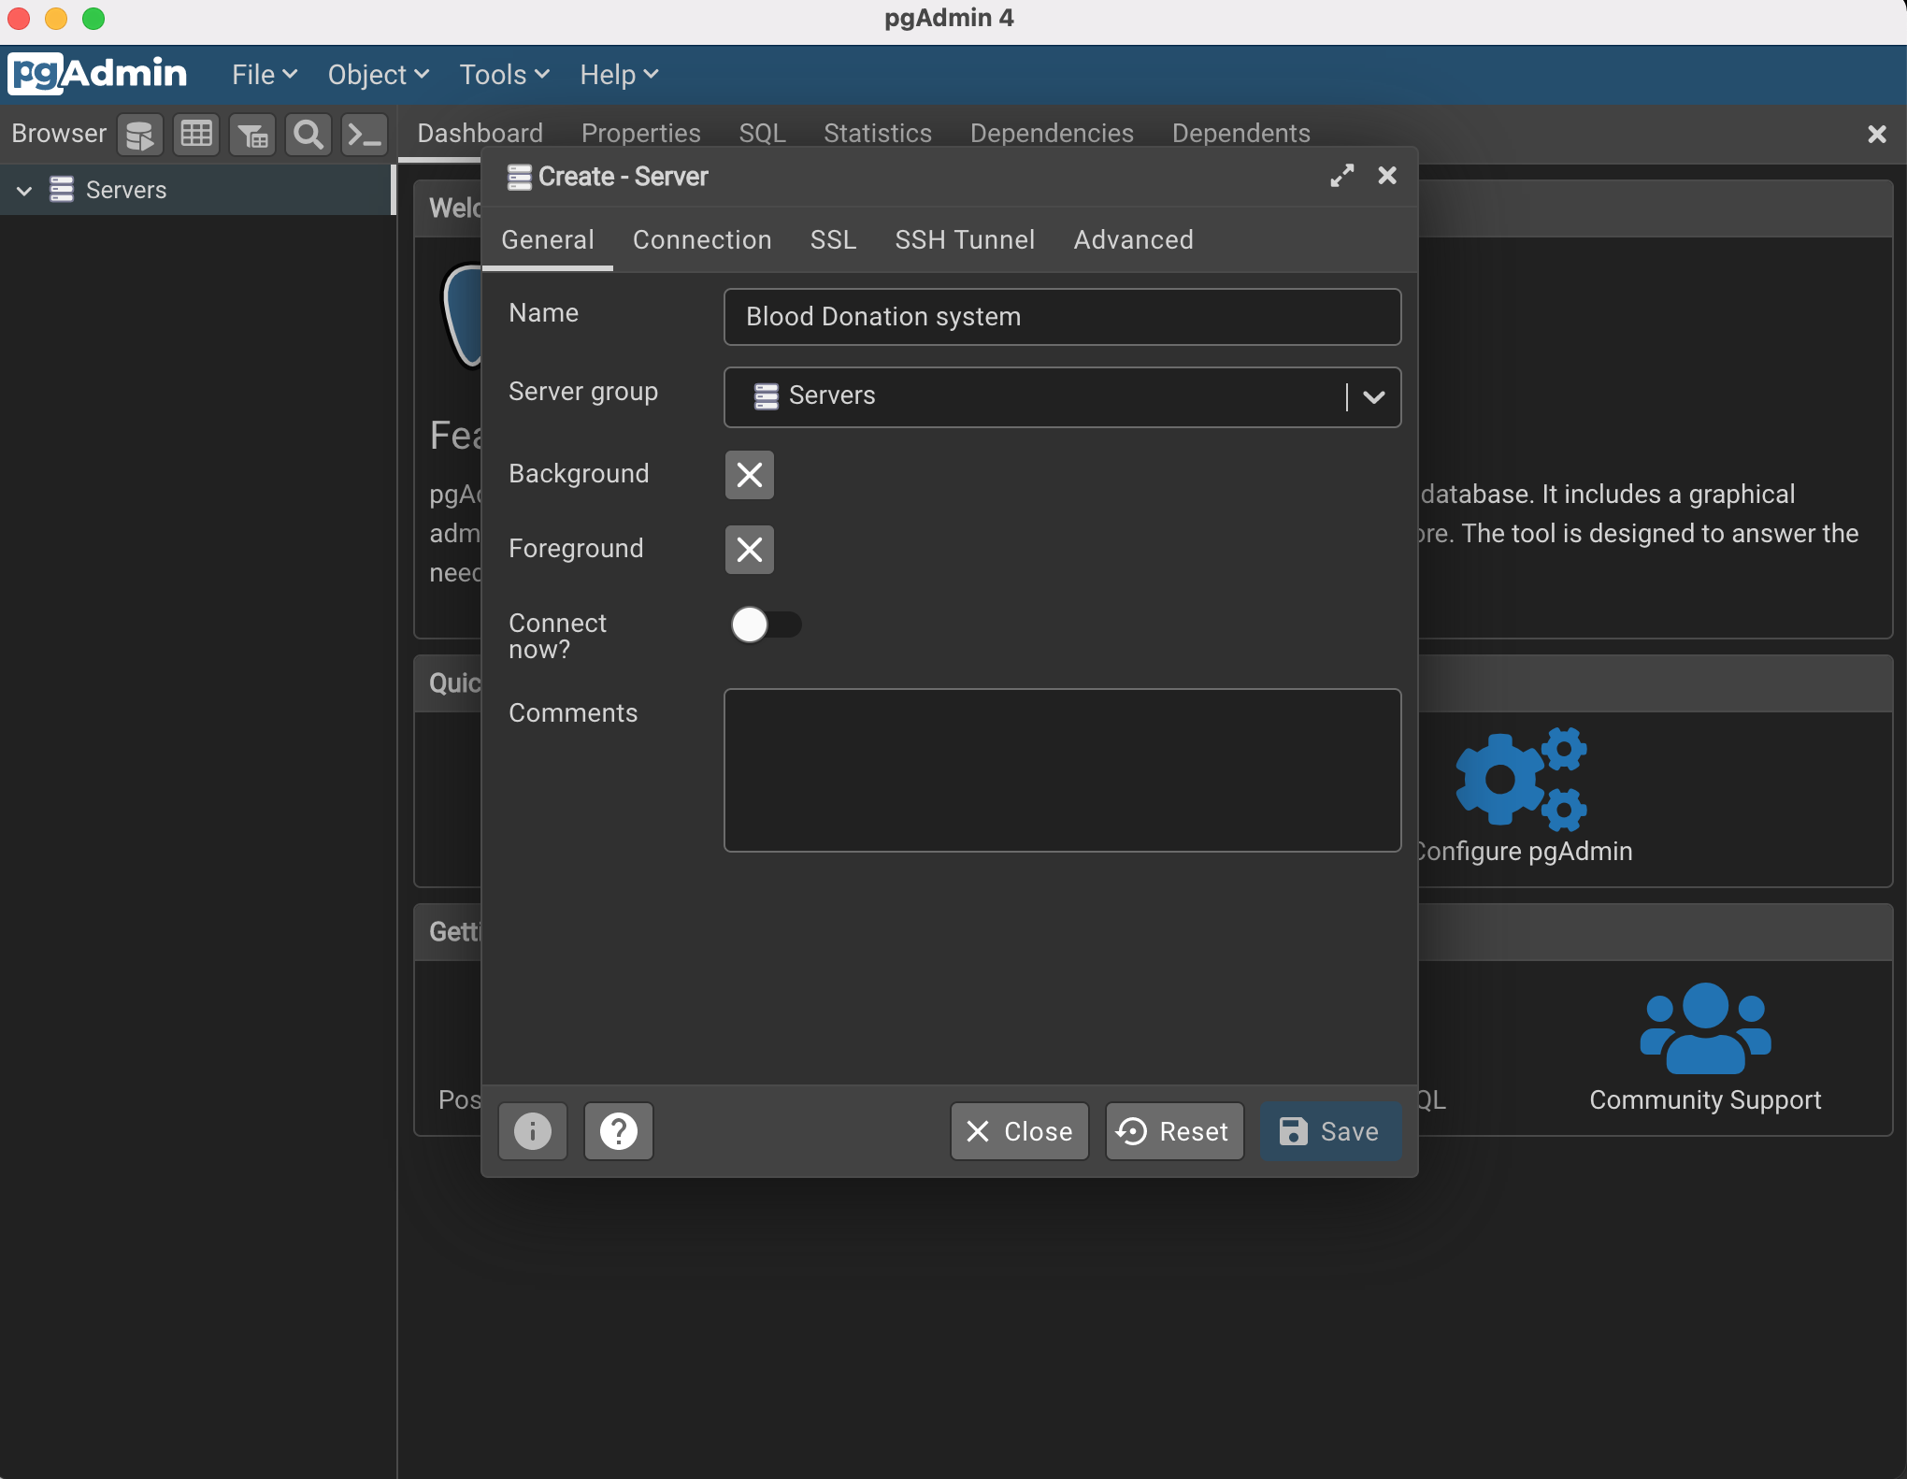

# Deployment Platform

## 6.1 Heroku:

Heroku is provides free deployment service. it provides free ram starting from 512MB and media storage.

## 6.2 S3 Bucket:

One limitation of using free Heroku is that after some time all the media is deleted. To tackle this problem we will be using S3 bucket by AWS which provides 5GB data with 2000 pull requests per month.

## 6.3 Heroku DB:

For database storage we will again be using Heroku. it provides upto 10,000 rows for free. These rows will be sufficient for the initial prototype

# Who Did What?

|  |  |
| --- | --- |
| **Name of the Team Member** | **Tasks done** |
| Ahmad Aslam | Process Selection, Development Environment preparation |
| Muhammad Bilal | Risk Management |
| Saad Azam | Gantt chart |

# Review checklist

Before submission of this deliverable, the team must perform an internal review. Each team member will review one or more sections of the deliverable.

|  |  |
| --- | --- |
| **Section** **Title** | **Reviewer Name(s)** |
| Risk Management, gantt chart | Ahmad Aslam |
| Process Selection, gantt chart | Muhammad Bilal |
| Process selection risk management | Saad Azam |